UNION student led organization
The purpose of the Union is to ensure the active participation of students in the social life of the university and to create a favorable environment for meeting their social, intellectual, creative, spiritual, and economic needs, as well as to promote the principles of sustainable development within the university community.

A student self-government body, UNION, operates within the university to address key issues related to improving student life, leisure activities, interaction with other universities, protection of students' rights, and more.
Its activities include:
- participation in collegial governing bodies (Academic Council, Ethics Council, Public Council, etc.);
- participation in the work of commissions and working groups (budget commission, benefits commission, etc.);
- protection and representation of students’ rights and interests;
- assistance in resolving educational, social, and other issues affecting students’ interests;
- creating conditions for the development of social responsibility among youth and their involvement in addressing pressing societal issues, including environmental and sustainability challenges;
- promotion of sustainable development values, environmental awareness, and responsible resource use among students;
- preservation and development of democratic traditions among students;
- support to governing bodies in solving educational and scientific tasks, organizing the educational and upbringing process, as well as in improving students’ leisure and living conditions.

Union Leaders:
 Arailym Bauyrzhankyzy President of the Higher Student Council “Union”
 Bekzat Zhumakhan Executive Vice President of the Higher Student Council “Union”

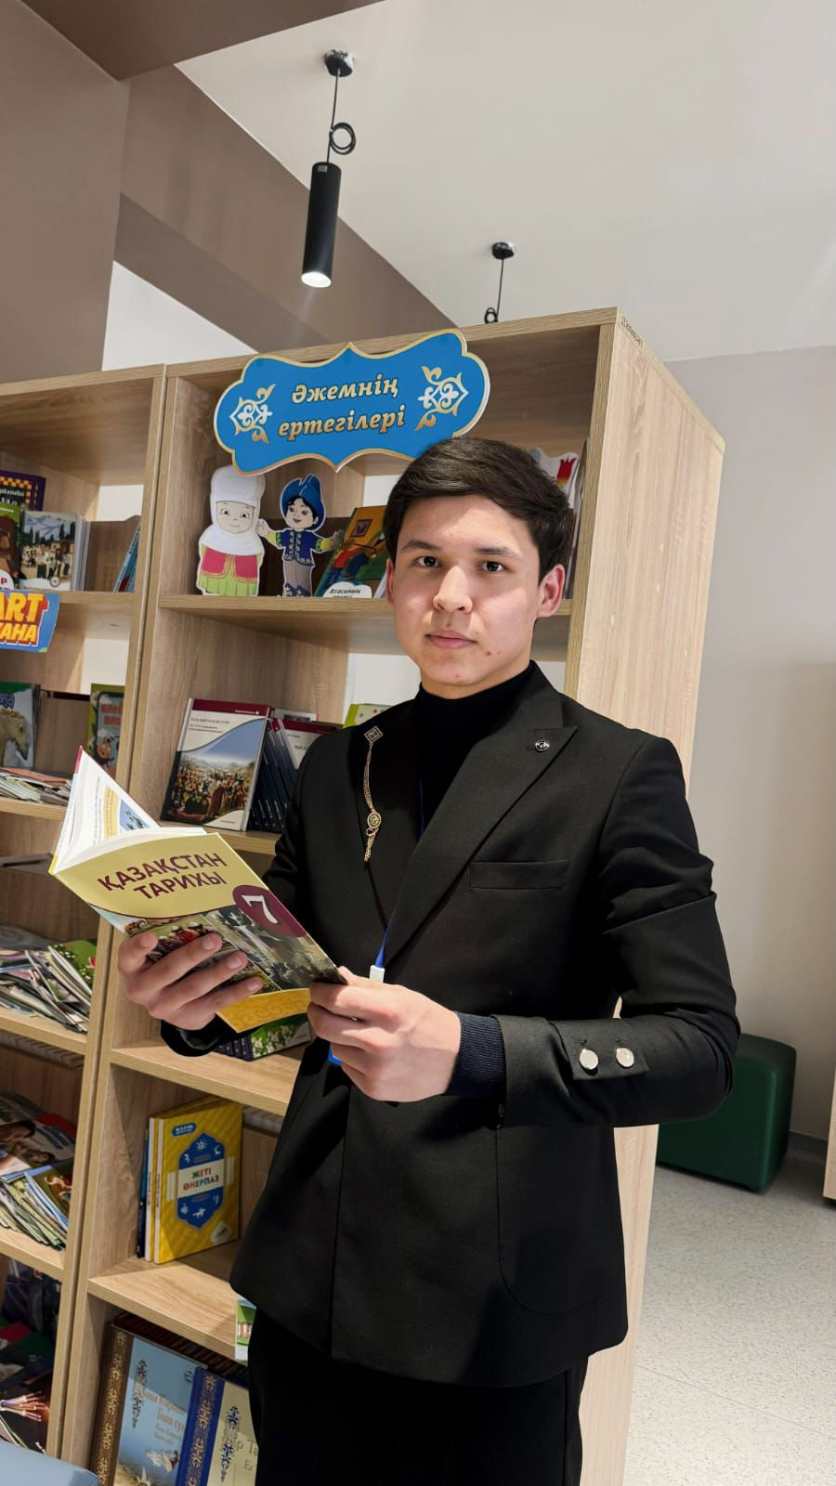 Adilzhan Amankul Vice-President for Academic Work of the Higher Student Council “Union”
 Zhasulan Amangeldiyev Vice-President for Research of the Higher Student Council “Union”

Sanzhar Orazaly Vice-President for Student Affairs of the Union Higher Student Council “Union”

Union Clubs:

https://old.yu.edu.kz/clubs/



Union Projects:
1. 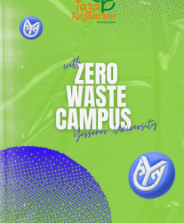 Zero Waste Campus

At Yessenov University, special waste separation bins have been installed across the campus to collect paper, plastic, glass, and other recyclable materials separately for proper recycling and reuse. Yessenov University promotes actions in minimizing environmental impact from the use of paper and plastic. Both paper and plastic production have significant environmental consequences, from resource extraction and manufacturing to waste disposal. Thus, YU has a 5-year contract with a local company which gathers paper and plastic waste coming out from Yessenov University. This action works quarterly, and every 3 months there is a delivery service from YU. It is also important to note that a graduate student of Yessenov University came up with the idea of collecting paper and plastic.
This initiative is part of the university’s broader commitment to building a green and sustainable campus and fostering an environmentally responsible culture among students and staff.
The university regularly organizes environmental awareness campaigns, workshops, and student-led eco-projects to promote waste reduction and recycling practices.
Collaboration with local waste management companies ensures that all sorted materials are properly recycled, reducing the overall amount of waste sent to landfills.
Through the Zero Waste Campus initiative, Yessenov University aims to minimize waste generation, encourage conscious consumption, and inspire the university community to take collective action for a cleaner, greener future.
https://www.instagram.com/p/DOnT-iLDEOx/
2. Green Transportation Initiatives 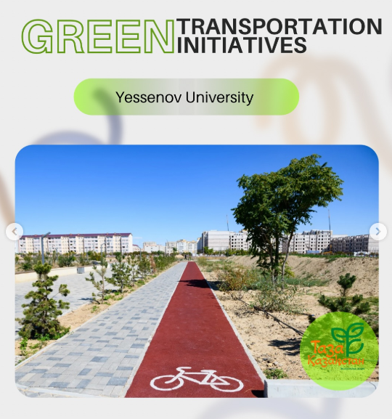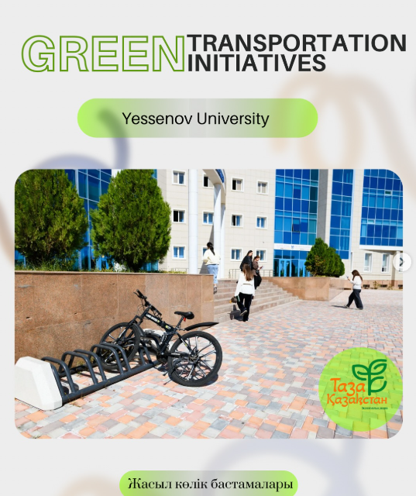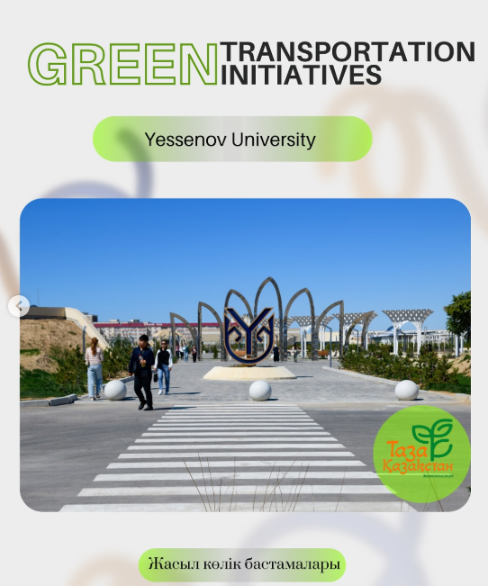
All campus locations are designed to be friendly for cyclists and pedestrians, featuring numerous vehicle-free pathways to enhance safety and accessibility.
Within the framework of the “Clean Kazakhstan” 2024–2029 Concept, Yessenov University has launched initiatives to promote the use of environmentally friendly transportation.
In December 2024, the university constructed a 786-meter bicycle lane, parking area, and pedestrian walkway in the Youth Park, which are now open for use by students and local youth.
The main goal of this project is to encourage young people to use public transport, bicycles, and walking as sustainable and healthy modes of mobility.
A strict 5 mph speed limit is enforced on all internal roads, complemented by dedicated bike lanes on nearby public streets. Each site is equipped with a diverse selection of bike racks to accommodate various styles and preferences. The university promotes cycling by offering free shower facilities for cyclists and implementing a “Bike to Work” program for staff members. Additionally, several events and initiatives encourage cycling, including group rides and workshops, while students benefit from a bike-sharing program that provides access to free bicycles.
https://www.instagram.com/p/DOoFNrajNrX/?img_index=1

3. https://www.instagram.com/p/DPqsKJ7jbN2/ “EcoBridge”

YU Volunteers took part in an international environmental campaign, demonstrating their commitment to sustainability and civic responsibility. The initiative, titled “EcoBridge — Azerbaijan — Kazakhstan,” brought together volunteers from both countries to work towards a common goal — protecting the Caspian Sea. Participants engaged in coastal clean-up activities, removing waste and raising awareness about marine pollution. The campaign also served as a platform for cultural exchange and collaboration among young people. Through joint efforts, volunteers highlighted the importance of preserving shared natural resources. YU Volunteers actively contributed to promoting environmental awareness within the local community. Their participation reflects the university’s dedication to sustainable development and global cooperation. Such initiatives strengthen international partnerships and inspire youth to take action for a cleaner future.

Union Rules, Plans, and Reports:
документтерді қою керек

