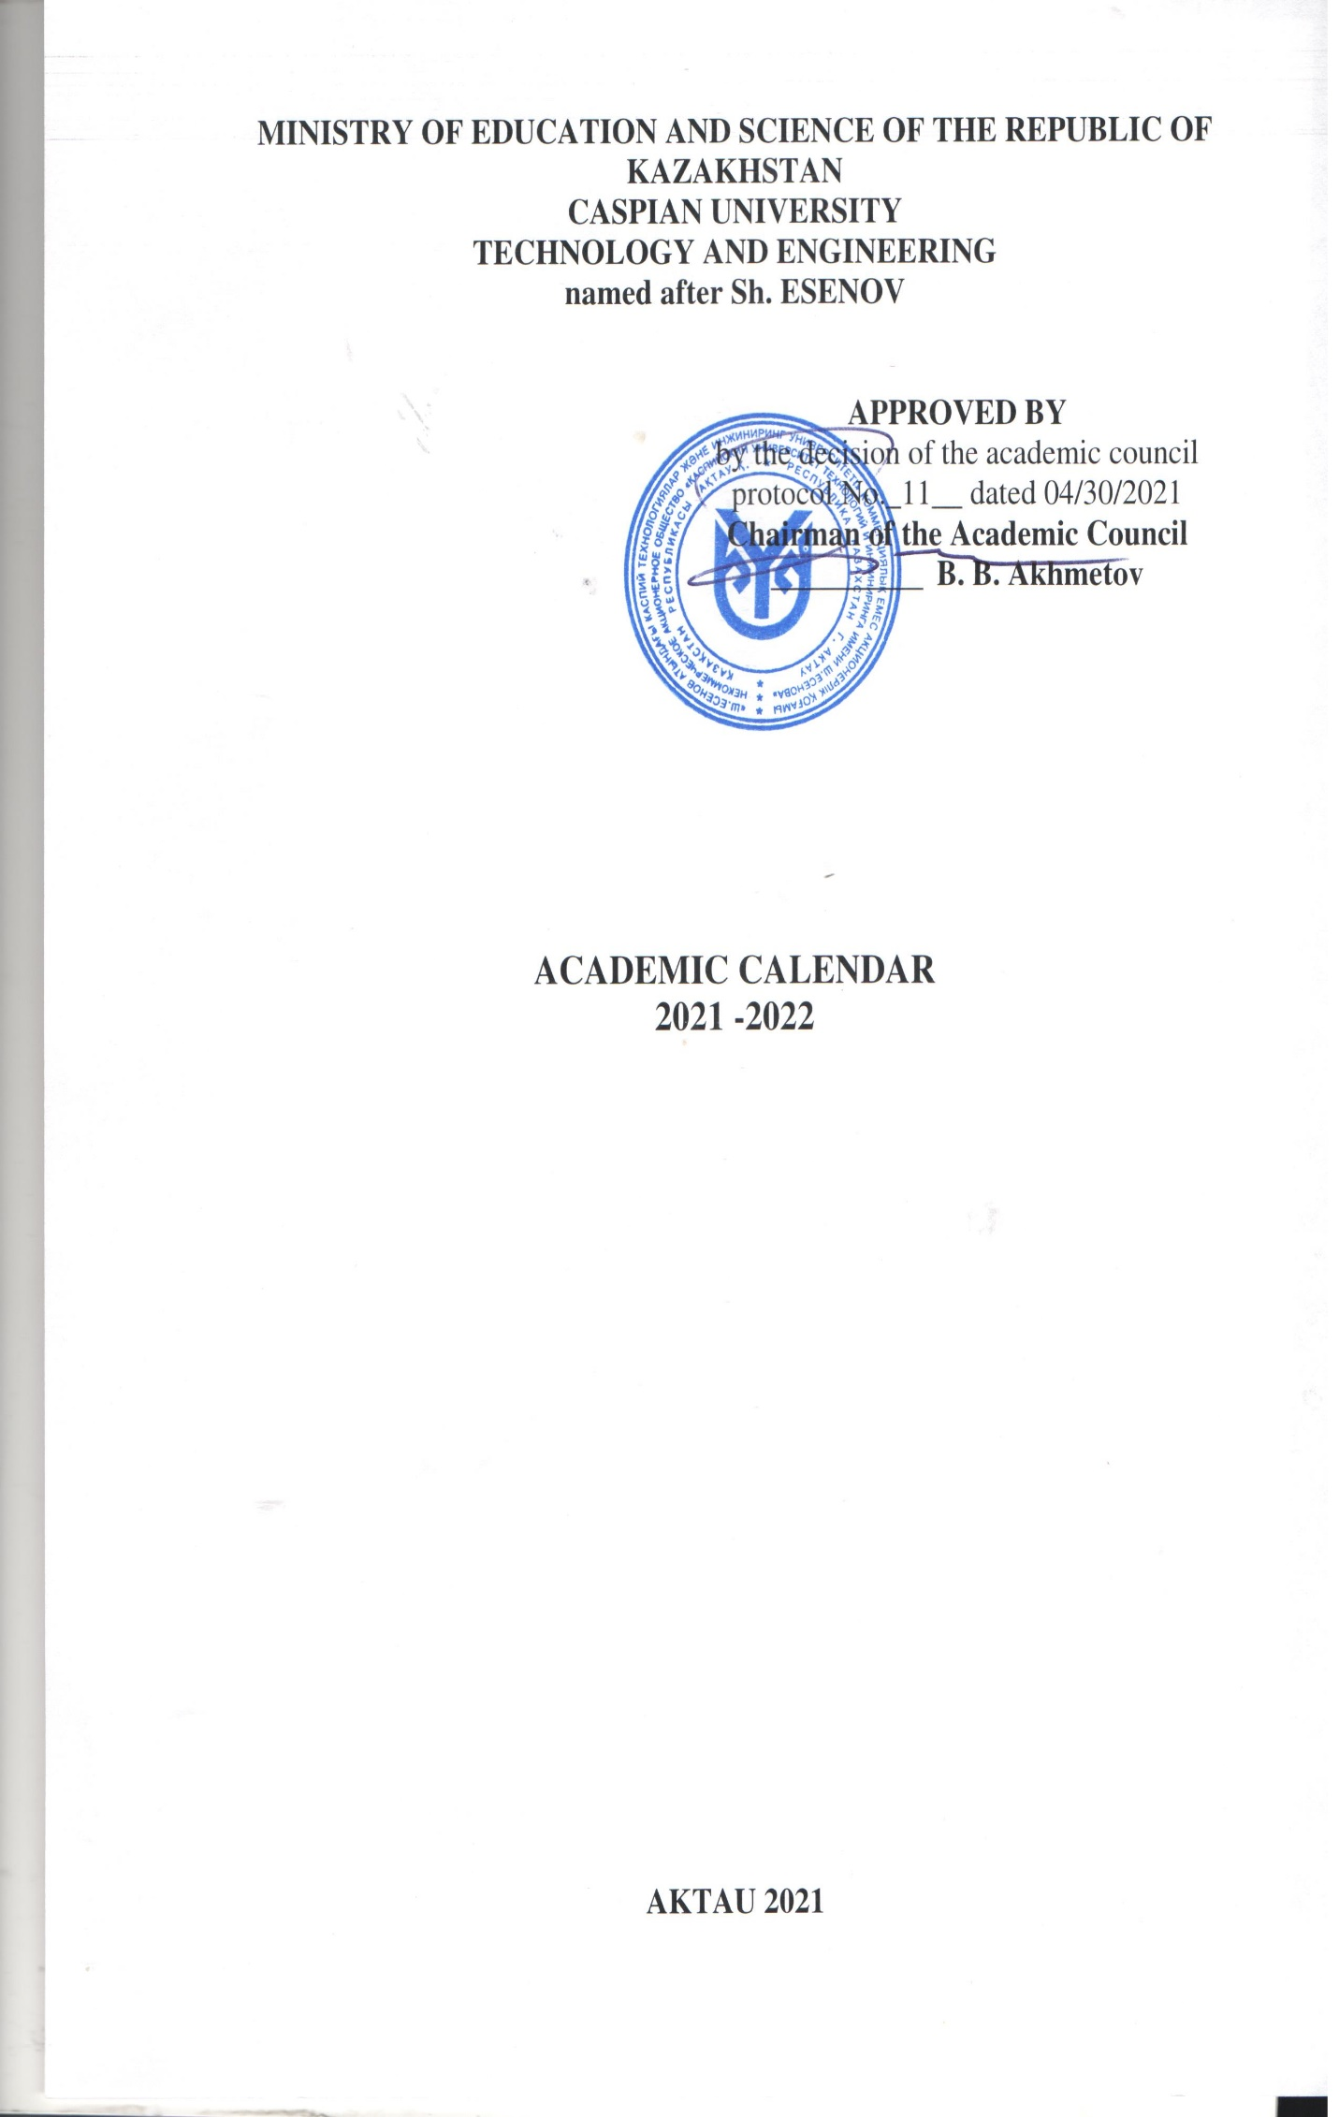

APPROVED BY
by the decision of the academic council
protocol No._11__ dated 04/30/2021

ACADEMIC CALENDAR
for the 2021-22 academic year
full-time form of study, full-time abbreviated form of study
(bachelor's degree)

Orientation week  (Registration for academic disciplines and the formation of IEP) | 23.08.2021-28.08.2021
AUTUMN SEMESTER | Deadlines
Constitution day | 30.08.2021
Day of Knowledge | 01.09.2021
Start of training sessions | 01.09.2021
Midterm I | 18.10.2021-23.10.2021
Day of the first president | 01.12.2021
Midterm II | 06.12.2021-11.12.2021
End of training sessions | 11.12.2021
Independence Day | 16.12.2021-17.12.2021
Exam session | 13.12.2021-08.01.2022
New Year | 01.01.2022-02.01.2022
Orthodox Christmas | 07.01.2022
Winter vacation | 10.01.2022-22.01.2022
SPRING SEMESTER | Deadlines
Start of training sessions | 24.01.2022
International Women's Day | 08.03.2022
Nauryz meiramy | 21.03.2022-23.03.2022
Midterm I | 14.03.2021-19.03.2021
Orientation week  (Registration for academic disciplines and the formation of IEP) | 18.04.2022-23.04.2022
The holiday of the unity of the people of Kazakhstan | 01.05.2022
Midterm II | 02.05.2022-07.05.2022
Day of Defender’of the Fatherland | 07.05.2022
Victory Day | 09.05.2022
End of training sessions | 07.05.2022
Exam session | 09.05.2022-28.05.2022
Military fees | 30.05.2022 - 02.07.2022
Graduation ceremony | 24.06.2022
Day of Capital city | 06.07.2022
Summer semester | 20.06.2022-30.07.2022
TEACHING PRACTICE
3 course 6В01501, 6В01502, 6В01503, 6В01504, 6В015088(4), 6В01505, 6В01506 | 31.01.22-05.03.22
3 course ,6В01701, 6В01703, 6В01705 | 28.02.22-02.04.22
3 course 6В01301, 6В01101, 6В01401, 6В01601, | 28.03.22-07.05.22
4 course 5В010200, 5В010300, 5В010900, 5В011000, | 18.10.2021-27.11.2021
1 course on the basis of the university | 28.02.22-02.04.22
LANGUAGE PRACTICE
3 course 6В02302 | 28.02.22-02.04.22
INTERNSHIP
2 курс 6В03104, 6В04201, 6В04103, 6В04101, 6В04106, 6В04109, 6В04102, 6В11101, 6В05201, 6В06102, 6В06103, 6В07208, 6В07210, 6В07109, 6В07111, 6В07106, 6В07303, 6В11201, 6В11301, 6В07308, 6В07307, 6В07502,6В11103,6В023003 | 30.05.2022-18.06.2022
3 course 6В03104, 6В04201, 6В04103, 6В04101, 6В04106, 6В04109, , 6В11101, 6В05201, 6В06102, 6В06103, 6В07208, 6В07210, 6В07109, 6В07111, 6В07106, 6В07102, 6В07303, 6В112016В11301, 6В07307, | 30.05.2022-18.06.2022
3 course participating in military training 6В03104, 6В04201, 6В04103, 6В04101, 6В04106, 6В04109, , 6В11101, 6В05201, 6В06102, 6В06103, 6В07208, 6В07210, 6В07109, 6В07111, 6В07106, 6В07102, 6В07303, 6В112016В11301, 6В07307, | 04.07.2022-23.07.2022
2 course based on TVE 6В04201, 6В06103, 6В07208, 6В07210, 6В07109, 6В07111, 6В07106, 6В07303, | 30.05.2022-18.06.2022
2 course based on TVE 6В04106 | 30.05.2022-25.06.2022
2 course based on TVE 6В04109 | 30.05.2022-09.07.2022
1 course on the basis of the university | 30.05.2022-18.06.2022
UNDERGRADUATE PRACTICE
4 course 5В020200, 5В060800, 5В070300, 5В070600, 5В071200, 5В071300, 5В071800, 5В072100, 5В072400, 5В072900, 5В073100, 5В090100,5В090700,5В010200,5В010300,5В010900, 5В011000,5В011300,5В011600,5В011800, 5В030100, 5В050600, 5В050700, 5В050800, 5В050900, 5В051000,5В090200, 5В010800, 5В011400, 5В011100, 5В011700, 5В011900, 5В020700 | 31.01.2022-19.03.2022
2 course (second degree)  6В07106,6В07210, 6В07303, 6В04201, 6В04103, 6В04102,6В01101,6В01301,6В01401,6В01705,6В01501,6В01703 | 24.01.2022-16.04.2022
3 course (post-college education) 6В06102, 6В06103, , 6В07210, 6В07109, 6В07111, 6В07106, , 6В07102, 6В07303, 6В11201, , 6В11301, 6В04201, 6В04103, 6В04101, 6В04106, 6В04109, 6В11101, 6В01301, 6В01101, 6В01401,6В01705 | 24.01.2022-16.04.2022
Undergraduate (swimming practice)
5 course 5В0715000 | 17.01.2022-16.04.2022
4 course (post-college education)5B071500 | 17.01.2022-16.04.2022
Industrial swimming practice
4 course 5В0715000 | 24.01.2022-16.07.2022
4 course 5В0715000 | 24.01.2022-11.06.2022
3rd course 6V07112, 6V07113, 6V07114 | 30.05.2022-16.07.2022
3 course participating in military training 6В07112, 6В07113, 6В07114 | 04.07.2022-20.08.2022
2nd course 6V07112, 6V07113, | 30.05.2022-25.06.2022
3rd course (post-college education) 6V07112, 6V07113 | 31.01.2022-18.06.2022
2 course (second degree) 6В07113 | 30.05.2022-09.07.2022
Undergraduate industrial practice
5 course 5В0715000 | 31.01.2022-09.04.2022
Internship
4 course 5В0715000 | 30.05.2022-02.07.2022
3 course 6В07115 | 30.05.2022-25.06.2022
2 course 6В07115 | 30.05.2022-11.06.2022
2 course ((second degree)) | 30.05.2022-11.06.2022
FINAL EXAMINATION
For graduation courses | 18.04.2022-09.07.2022
Preparation of the graduation project | 01.11.2022-16.04.2022
Registration of the diploma project | 18.04.2022-14.05.2022
Preliminary defense of the thesis project | 16.05.2022-04.06.2022
Defense of a thesis project or complex exam | 06.06.2022-25.06.2022
Preparation and submission of the report to the AС | 27.06.2022-09.07.2022

APPROVED BY
by the decision of the academic council protocol No._11__ dated 04/30

ACADEMIC CALENDAR
for the 2021-22 academic year
full-time education profile direction (1 year), EP EMBA (1 year)
(magistracy)

Orientation week (Registration for academic disciplines and the formation of IEP) | 23.08.2021-28.08.2021
AUTUMN SEMESTER | Deadlines
Constitution day | 30.08.2021
Day of Knowledge | 01.09.2021
Start of training sessions | 01.09.2021
Midterm II | 18.10.2021-23.10.2021
Day of the first president | 01.12.2021
Midterm I | 06.12.2021-11.12.2021
End of training sessions | 11.12.2021
Independence Day | 16.12.2021-17.12.2021
Exam session | 13.12.2021-02.01.2022
New Year | 01.01.2022-02.01.2022
Orthodox Сhristmas | 07.01.2022
SPRING SEMESTER | Deadlines
International Women's Day | 08.03.2022
Nauryz meiramy | 21.03.2022-23.03.2022
The holiday of the unity of the people of Kazakhstan | 01.05.2022
Defender of the Fatherland Day | 07.05.2022
Victory Day | 09.05.2022
Capital Day | 06.07.2022
RESEARCH
Experimental research work of a master's student of a specialized master's degree (2021) | 17.01.2022-16.04.2022
Scientific internship | 21.02.2022-26.02.2022
ЕМВА | 01.11.2021-27.11.2021  03.01.2022-09.04.2022
INTERNSHIP
7М04102, 7М04103, 7М04101,7М04104 | 17.01.2022-19.02.2022
FINAL EXAMINATION
For graduation courses | 18.04.2022-09.07.2022
Registration of a master's project | 18.04.2022-14.05.2022
Preliminary defense of a master's project | 16.05.2022-04.06.2022
Master's project defense | 06.06.2022-25.06.2022
Preparation and submission of the report to the AC | 27.06.2022-09.07.2022

APPROVED BY
by the decision of the academic council protocol No._11__ dated 04/30

ACADEMIC CALENDAR
for the 2021-22 academic year
full-time course of study, profile direction (1.5 years)
(magistracy)

Orientation week(Registration for academic disciplines and the formation of IEP) |  | 23.08.2021-28.08.2021
AUTUMN SEMESTER |  | Deadlines
Constitution day |  | 30.08.2021
Day of Knowledge |  | 01.09.2021
Start of training sessions |  | 01.09.2021
Midterm I |  | 18.10.2021-23.10.2021
Day of the first president |  | 01.12.2021
Midterm II |  | 06.12.2021-11.12.2021
End of training sessions |  | 11.12.2021
Independence Day |  | 16.12.2021-17.12.2021
Exam session |  | 13.12.2021-02.01.2022
New Year |  | 01.01.2022-02.01.2022
An Orthodox xmas |  | 07.01.2022
Winter vacation |  | 03.01.2022-22.01.2022
SPRING SEMESTER |  | Deadlines
Start of training sessions |  | 24.01.2022
International Women's Day |  | 08.03.2022
Nauryz meiramy |  | 21.03.2022-23.03.2022
Midterm I |  | 14.03.2021-19.03.2021
Orientation week (enrollment in academic disciplines and the formation of IEP for the next academic year) |  | 18.04.2022-23.04.2022
The holiday of the unity of the people of Kazakhstan |  | 01.05.2022
Midterm II |  | 02.05.2022-07.05.2022
Day of Defenders of the Fatherland |  | 07.05.2022
Victory Day |  | 09.05.2022
End of training sessions |  | 07.05.2022
Exam session |  | 09.05.2022-28.05.2022
Capital Day |  | 06.07.2022
Summer semester |  | 20.06.2022-30.07.2022
RESEARCH
EIRM of the profile magistracy
(2021 year admission) 1 семестр |  | 01.11.2021-04.12.2021
(2021 year admission) 2 семестр |  | 21.03.2022-23.04.2022
(2020 year admission) 3 семестр |  | 11.10.2021-04.12.2021
International internship |  | 22.11.2021-27.11.2021
INTERNSHIP
2nd year of study 7М05201, 7М07208, 7М07109, 7М06102, 7М07210, 7М07105, 7М07102,7М07108,7М07112 |  | 06.09.2021-13.11.2021
FINAL EXAMINATION
For graduation courses |  | 06.12.2021-26.02.2022
Registration of a master's project |  | 04.04.2022-30.04.2022
Preliminary defense of a master's project |  | 02.05.2022-28.05.2022
Master's project defense |  | 30.05.2022-18.06.2022
Preparation and submission of the report to the AK |  | 20.06.2022-25.06.2022

APPROVED BY
by the decision of the academic council protocol No._11__ dated 04/30

ACADEMIC CALENDAR
for the 2021-22 academic year
full-time education scientific and pedagogical direction (2 years),
EP MBA (2 years) (magistracy)

Orientation week (enrollment in academic disciplines and the formation of IEP) |  | 23.08.2021-28.08.2021
AUTUMN SEMESTER |  | Deadlines
Constitution day |  | 30.08.2021
Knowledge day |  | 01.09.2021
Start of training sessions |  | 01.09.2021
Midterm II |  | 18.10.2021-23.10.2021
Day of the first president |  | 01.12.2021
Midterm II |  | 06.12.2021-11.12.2021
End of training sessions |  | 11.12.2021
Independence Day |  | 16.12.2021-17.12.2021
Exam session |  | 13.12.2021-02.01.2022
New Year |  | 01.01.2022-02.01.2022
An Orthodox xmas |  | 07.01.2022
Winter vacation |  | 03.01.2021-22.01.2021
SPRING SEMESTER |  | Deadlines
Start of training sessions |  | 24.01.2022
International Women's Day 8 March |  | 08.03.2022
Nauryz meiramy |  | 21.03.2022-23.03.2022
Midterm II |  | 14.03.2021-19.03.2021
Orientation week (enrollment in academic disciplines and the formation of IEP for the next academic year) |  | 18.04.2022-23.04.2022
The holiday of the unity of the people of Kazakhstan |  | 01.05.2022
Midterm II |  | 02.05.2022-07.05.2022
Day of Defender of the Fatherland |  | 07.05.2022
Victory Day |  | 09.05.2022
End of training sessions |  | 07.05.2022
Exam session |  | 09.05.2022-28.05.2022
Capital city Day |  | 06.07.2022
Summer semester |  | 20.06.2022-30.07.2022
RESEARCH
NIRM scientific and pedagogical magistracy (2021 admission year) |  | 25.10.2021-11.12.2021
NIRM scientific and pedagogical magistracy (2021 admission year) |  | 21.03.2022-07.05.2022
NIRM scientific and pedagogical magistracy (2020 admission) |  | 01.11.2021-04.12.2021
NIRM scientific and pedagogical magistracy (2020 admission) |  | 24.01.2022-26.02.2022
7М04104 МВА (2020 admission) |  | 01.11.2021-13.11.2021  03.01.2022-26.02.2022
7М04104 МВА (2021 admission year) |  | 04.10.2021-11.12.2021  03.01.2022-12.03.2022
Scientific internship 2 year of study 7М01301, 7М01101, 7М01501, 7М01502, 7М01503, 7М01701, 7М01703, 7М04103, 7М04101, 7М04102, 7М05201, 7М06102, 7М07208, 7М07210, 7М07109, 7М07105, 7М07102, 7М07108, 7М07112 |  | 14.02.2022-19.02.2022
Scientific internship 1 year of study 7М04104 |  | 03.01.2022-22.01.2022
RESEARCH PRACTICE
2nd year of study 7М01301, 7М01101, 7М01501, 7М01502, 7М01503, 7М01701, 7М01703, 7М04103, 7М04101, 7М04102, 7М05201, 7М06102, 7М07208, 7М07210, 7М07109, 7М07105, 7М07102, 7М07108, 7М07112 |  | 24.01.2022-16.04.2022
Internship
2nd year of study 7М04104 |  | 24.01.2022-19.03.2022
TEACHING PRACTICE
2nd year of study 7М01301, 7М01101, 7М01501, 7М01502, 7М01503, 7М01701, 7М01703, 7М04103, 7М04101, 7М04102,7М04104, 7М05201, 7М06102, 7М07208, 7М07210, 7М07109, 7М07105, 7М07102, 7М07108, 7М07112 |  | 13.09.2021-09.10.2021
FINAL EXAMINATION
For graduation courses |  | 18.04.2022-09.07.2022
Registration of a master's thesis |  | 18.04.2022-14.05.2022
Preliminary defense of a master's thesis |  | 16.05.2022-04.06.2022
Master's thesis defense |  | 06.06.2022-25.06.2022
Preparation and submission of the report to the AK |  | 27.06.2022-09.07.2022

APPROVED BY
By the decision of the academic council
protocol No._11__ dated 04/30/2021

ACADEMIC CALENDAR
for the 2021-22 academic year
DOCTORATE
Orientation week (enrollment in academic disciplines and the formation of IEP) | 23.08.2021-28.08.2021
AUTUMN SEMESTER | Deadlines
Constitution day | 30.08.2021
Knowledge day | 01.09.2021
Start of training sessions | 01.09.2021
Midterm I | 18.10.2021-23.10.2021
Day of the first president | 01.12.2021
Midterm II | 06.12.2021-11.12.2021
End of training sessions | 11.12.2021
Independence Day | 16.12.2021-16.12.2021
Exam session | 13.12.2021-02.01.2022
New Year | 01.01.2022-02.01.2022
An Orthodox Christmas | 07.01.2022
Winter vacation | 03.01.2022-15.01.2022
SPRING SEMESTER | Deadlines
International Women's Day | 08.03.2022
Nauryz meiramy | 21.03.2022-23.03.2022
Orientation week (enrollment in academic disciplines and the formation of IEP for the next academic year)
The holiday of the unity of the people of Kazakhstan | 01.05.2022
Defender of the Fatherland Day | 07.05.2022
Victory Day | 09.05.2022
Graduation ceremony for graduates
Capital Day | 06.07.2022
Summer semester | 20.06.2021-30.07.2021
RESEARCH
NIRD - 1st year | 01.11.2021-25.12.2021
NIRD - 2nd year | 06.09.2021-25.12.2021
NIRD - 3rd year | 30.08.2021-15.01.2022
NIRD 3 years | 17.01.2022-02.04.2022
Scientific internship 3 years | 14.02.2022-19.02.2022
NIRD - 1st year | 03.01.2022-27.08.2022
NIRD - 2nd year | 03.01.2022-27.08.2022
TEACHING PRACTICE
1st year | 14.02.2022-23.04.2022
RESEARCH PRACTICE
2nd year | 06.09.2021-13.11.2021
FINAL EXAMINATION
For graduation courses | 04.04.2022-25.06.2022

